Railway/Highway At-Grade Crossing Surface Rehabilitation Manual: Recommendations and Guides
Brett R. Malloy¹, Macy L. Purcell², Jerry G. Rose²

¹ Integrated Engineering, Lexington, KY
² Department of Civil Engineering, University of Kentucky, Lexington, KY

Railway/Highway At-Grade Crossing Surface Management involves selecting the most cost-effective rehabilitation technique that will provide safe, smooth, high performance, long-life, serviceable crossings for the motoring public. This report [1] functions as a manual that offers step-by-step guidance to see a project from its planning stages through to its implementation and post-construction management. This manual instructs users on executing the three main project phases: 1) pre-project administration, 2) rehabilitation activities, and 3) post-project administration. Pre-Project Administration entails reviewing historical maintenance cost data for the crossing, which lets engineers determine the optimal rehabilitation method using an intuitive decision-option diagram, categorizing/separating major work and cost items, calculating unit costs for the major work and cost items, evaluating the cost effectiveness of various alternatives, and selecting a design that meets all the criteria set by the Kentucky Transportation Cabinet (KYTC).
Next, Rehabilitation Activities include executing the design according to the chosen specifications. Based on the outcome of Pre-Project Administration, this may involve a process as simple as 1) adjusting/improving the highway pavement approaches, which does not impinge on the other aspects of the crossing. Or if only the crossing surface has deteriorated, 2) removing and replacing the crossing surface material may be necessary. If it is obvious that the crossing’s structural support is insufficient for the loadings, 3) removing and replacing the structural sub-layers, track, and crossing surface will be required. Post-Project Administration occurs after the project’s completion. This phase begins with post-installation inspection, which can uncover any problems that need to be resolved. Common post-installation activities include reinstalling drainage, disposing of the released track material, and clearing vegetation from the immediate crossing area. With this guidance, KYTC is in a better position to provide a safe, smooth, cost-effective, economical crossing with long service life.

Determination of Rehabilitation Procedure
Adjustments/Improvements to the Highway Pavement Approaches
In many cases, the highway approaches to a crossing are the primary – and sometimes only – factor contributing to its roughness and suboptimal performance. The needed solution can vary, and hinges on the scope and magnitude of the problem. For example, if the only problem is relatively simple (e.g. stemming from rough pavement surfaces), the solution is likely to be straightforward. However, if the cause is highly complex, such as the presence of a vertical geometrical incompatibility, the corrective action will be more involved. Figure 1 is a decision option diagram that guides decision making when dealing with adjustments/improvements to the highway pavement approaches.

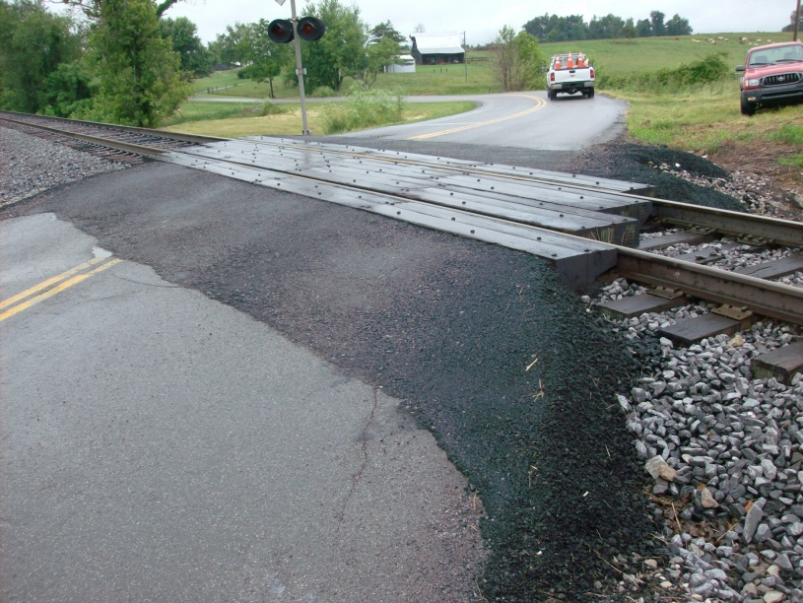
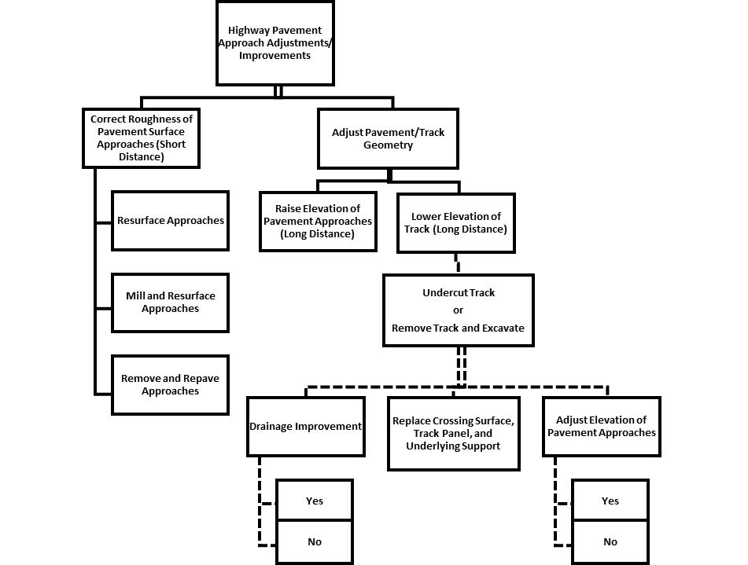
Renewal of Crossing Surface
Figure 2. All Timber Crossing Surface, Approaches too Short, Only Need to Lengthen Approaches to Restore Acceptable Quality Crossing.

Figure 1. Adjustments/Improvements to the Highway Pavement Approaches Decision-Option Diagram, only Activities required to Restore Acceptable Quality Crossing.

Figure 3 contains a decision-option diagram that outlines the primary considerations for crossing surface renewal; it provides a list of potential tie and crossing surface replacements.

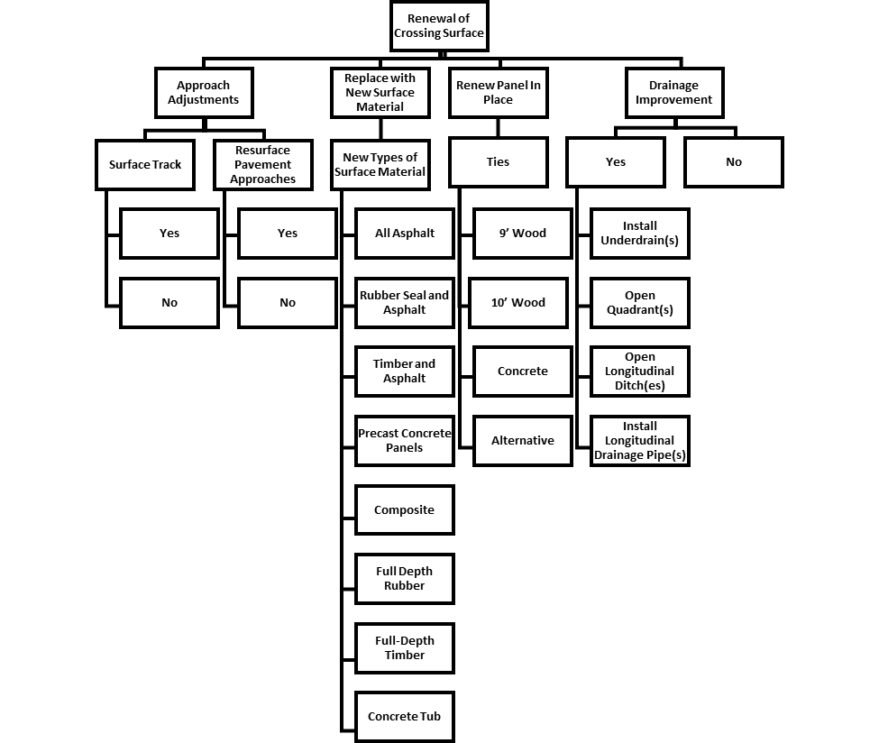
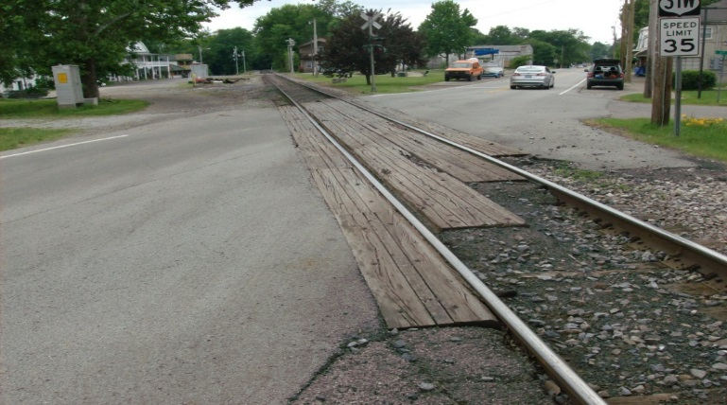
Figure 3. Renewal of Crossing Surface Decision-Option Diagram, only Activity Required to Restore Acceptable Quality Crossing.

Figure 4. Deteriorated All-Timber Crossing, still Smooth, Only Need to Replace Crossing Surface to Restore Acceptable Quality Crossing.

Complete Renewal of Crossing Surface, Track Panel, and Underlying Support
Figure 5 represents the decision sequence that is applied when a crossing surface, track panel, and underlying support are completely renewed. Under this scenario, all present elements are totally removed and replaced with new materials having increased and therefore adequate load-carrying properties. Also, the adequacy of the drainage should be addressed and appropriate improvements selected. Usually, this process entails assessing pavement approaches, and in many cases they will be raised to match the adjusted top-of-rail elevations of the track. The track approaches are typically adjusted vertically and elevated slightly, as the crossing area is surfaced before the new surface crossing is set into place.
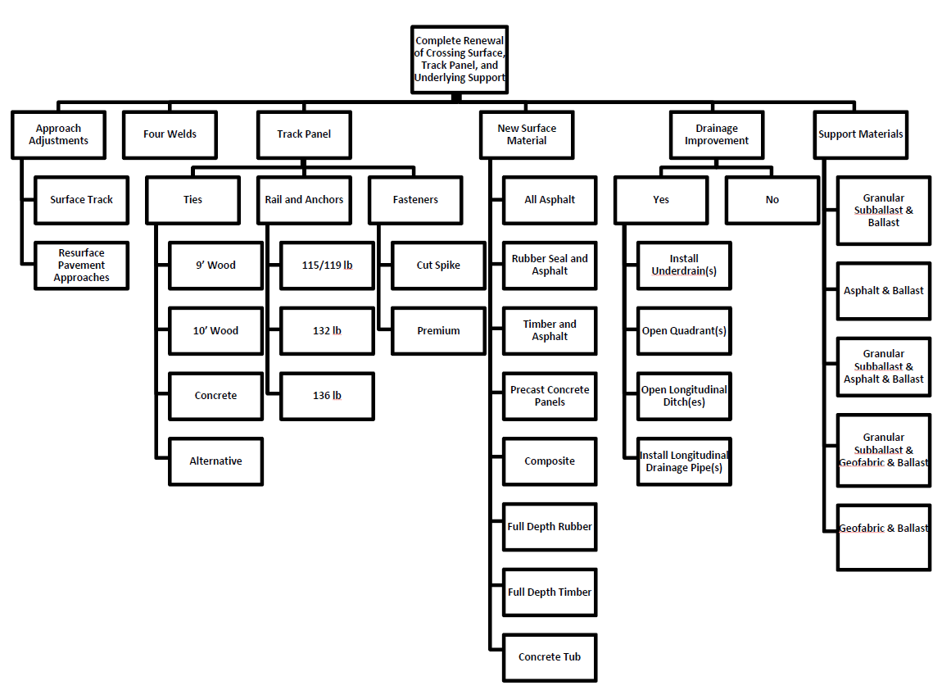
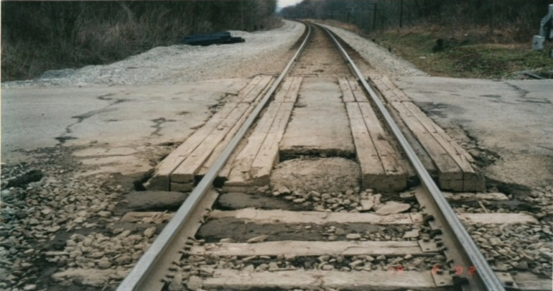
Figure 5. Complete Renewal of Crossing Surface, Track Panel, and Underlying Trackbed Support Decision-Option Diagram, Complete Renewal Required to Restore Acceptable Quality Crossing.

Figure 6. Poor Quality Support, Complete Removal of Trackbed Support and Surface Required to Restore Acceptable Quality Crossing.

Summary
This Railway/Highway At-Grade Crossing Surface Rehabilitation Manual offers guidance to engineers and project planners for designing, constructing, and managing railway/highway crossing rehabilitation projects. The manual includes information on pre-project administration, project execution, and post-project management and oversight. Suggestions are provided for determining the most cost-effective rehabilitation procedure, techniques to insure the appropriate installation procedures are followed onsite, and instructions for post-project administration and inspection procedures. The primary goal of this manual is to aid with the implementation of a crossing rehabilitation program; all of its guidance underscores the importance of achieving cost effective solutions through the use of best practices to build crossings that are safe and smooth, perform at a high level, and have a long service life, which benefits railroads as well the driving public.

Reference
[1]. Malloy, B R., M. L. Purcell and J. G. Rose, Research Report KTC-14-19/SPR452-13-4F. “Railway/Highway At-Grade Crossing Surface Rehabilitation Manual: Recommendations and Guides,” Kentucky Transportation Center, University of Kentucky, December, 2014, 60 pages.
The authors would like to thank the National University Rail (NURail) Center, a US DOT-OST Tier 1 University Transportation Center for sponsoring this study.

